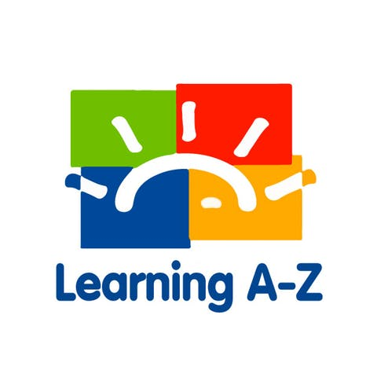
Dear Parent or Guardian:

Your child has access to award-winning digital resources through Kids A-Z, Learning A-Z's website created for students. After your child logs in, each website your child's teacher has subscribed to is shown. Your child can work on assignments or select other resources for reading and writing practice.

Website Resources for Your Student
Thousands of leveled books and resources in printable and digital formats

Access resources on mobile devices by downloading the Kids A-Z app from the app store or on a computer.

Kids A-Z Login Instructions
Step 1: Go to www.kidsa-z.com or the Kids A-Z App
Step 2: Enter or choose the teacher's username, sdelpy0
Step 3: Your child finds his or her username on the class chart
Step 4: Your child enters his or her password:

